Introduction to the EU

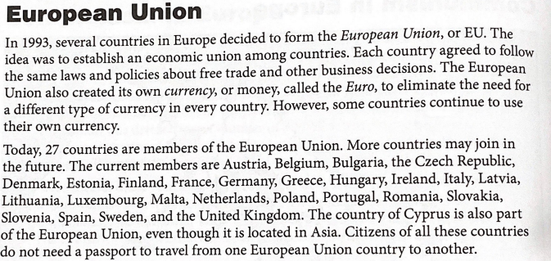

Read each statement. Highlight yes if it is true or no if it is false. Use the information above to help you.

1. The European Union was formed in 1993. YES OR NO
2. Members of the EU follow the same policies on free trade. YES OR NO
3. Every country of the EU uses its own separate currency. YES OR NO
4. Russia is a country in the EU. YES OR NO
5. EU residents need a passport to travel to other EU countries. YES OR NO
6. There are 27 members of the European Union. YES OR NO
7. No more countries can join the European Union. YES OR NO
8. Bulgaria is a member of the EU. YES OR NO
9. The United Kingdom is not an EU member. YES OR NO
10. Cyprus is a country in Europe. YES OR NO